Assignment 5:
Question1
Implement a simple Implicit Intent to open a URL in browser.

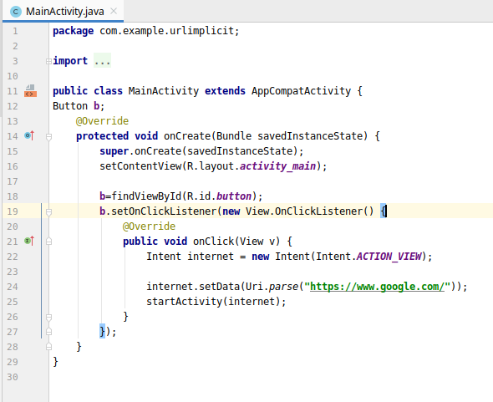
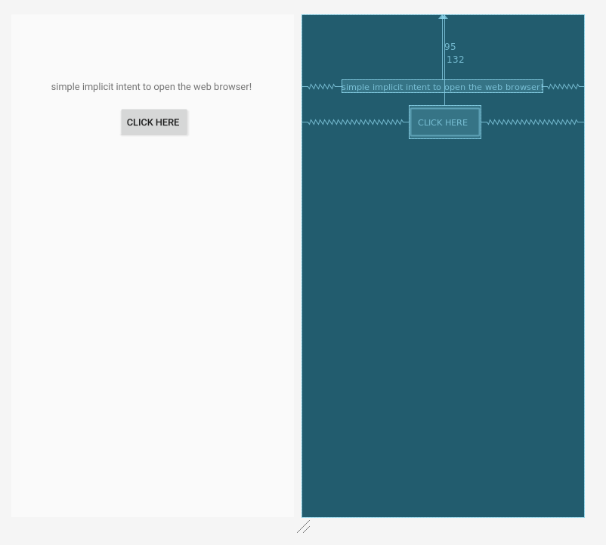

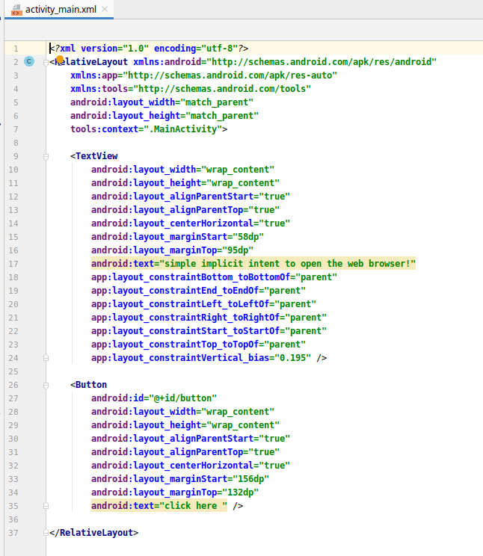

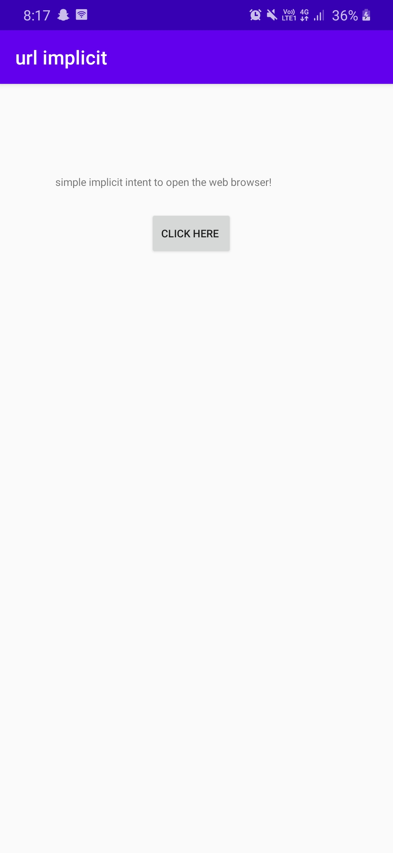

ScreenShot

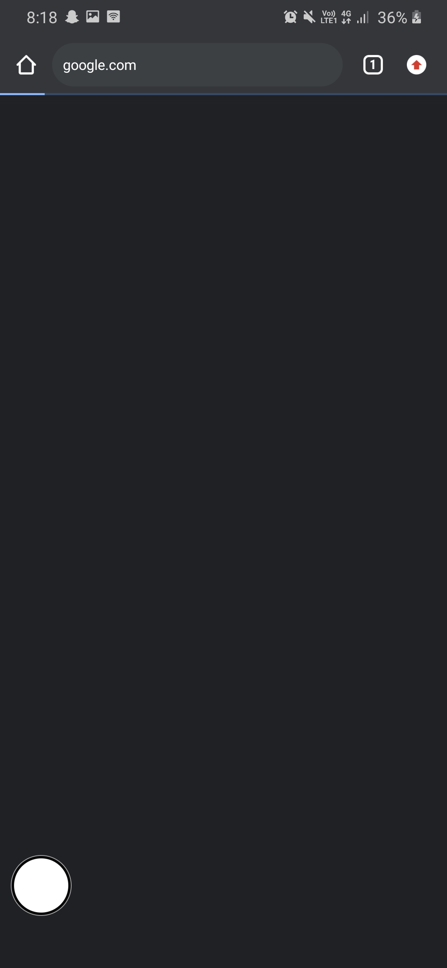

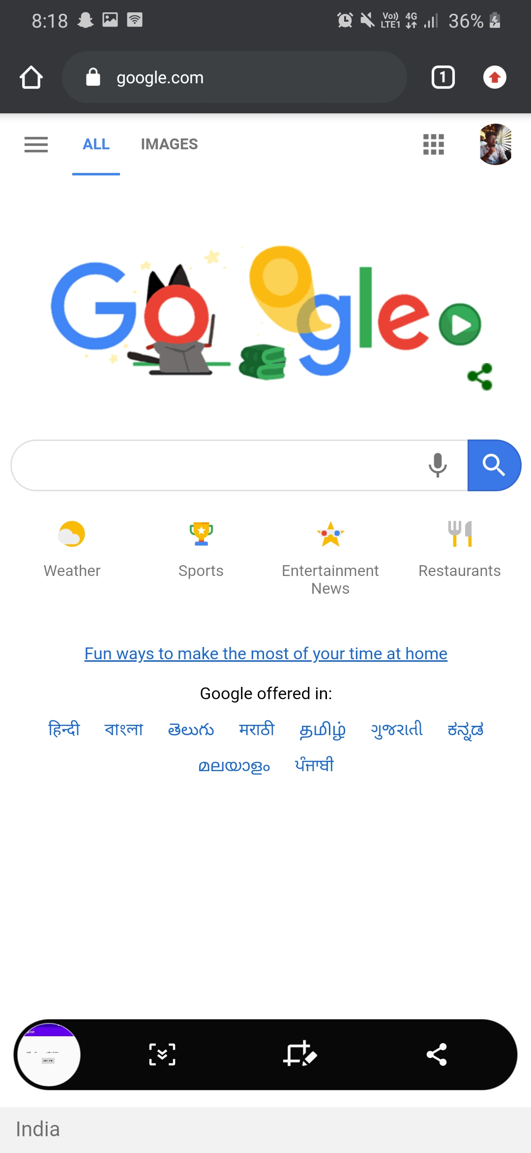

Question2
Explain different Intent actions and categories.

ACTION_ALL_APPS | List all the applications available on the device.
ACTION_ANSWER | For handling phone calls
ACTION_ATTACH_DATA | Used to indicate that some piece of data should be attached to some other place
ACTION_BATTERY_CHANGED | This is a sticky broadcast containing the charging state, level, and other information about the battery.
ACTION_BATTERY_LOW | This broadcast corresponds to the "Low battery warning" system dialog.
ACTION_BATTERY_OKAY | This will be sent after ACTION_BATTERY_LOW once the battery has gone back up to an okay state.
ACTION_BOOT_COMPLETED | This is broadcast once, after the system has finished booting.
ACTION_BUG_REPORT | Show activity for reporting a bug
ACTION_CALL | Perform a call to someone specified by the data.
ACTION_CALL_BUTTON | The user pressed the "call" button to go to the dialer or other appropriate UI for placing a cal
ACTION_CAMERA_BUTTON | The "Camera Button" was pressed.
ACTION_CHOOSER | Display an activity chooser, allowing the user to pick what they want to before proceeding.
ACTION_CONFIGURATION_CHANGED | The current device Configuration (orientation, locale, etc) has changed.
ACTION_DATE_CHANGED | The date has changed.
ACTION_DEFAULT | A synonym for ACTION_VIEW, the "standard" action that is performed on a piece of data.
ACTION_DELETE | Delete the given data from its container.
ACTION_DEVICE_STORAGE_LOW | A sticky broadcast that indicates low memory condition on the device.
ACTION_DEVICE_STORAGE_OK | Indicates low memory condition on the device no longer exists
ACTION_DIAL | Dial a number as specified by the data
ACTION_DOCK_EVENT | A sticky broadcast for changes in the physical docking state of the device.
ACTION_DREAMING_STARTED | Sent after the system starts dreaming.
ACTION_DREAMING_STOPPED | Sent after the system stops dreaming.
ACTION_EDIT | Provide explicit editable access to the given data.
ACTION_FACTORY_TEST | Main entry point for factory tests
ACTION_GET_CONTENT | Allow the user to select a particular kind of data and return it.
ACTION_GTALK_SERVICE_CONNECTED | A GTalk connection has been established.
ACTION_GTALK_SERVICE_DISCONNECTED | A GTalk connection has been disconnected.
ACTION_HEADSET_PLUG | Wired Headset plugged in or unplugged.
ACTION_INPUT_METHOD_CHANGED | An input method has been changed.
ACTION_INSERT | Insert an empty item into the given container.
ACTION_INSERT_OR_EDIT | Pick an existing item, or insert a new item, and then edit it.
ACTION_INSTALL_PACKAGE | Launch application installer.
ACTION_LOCALE_CHANGED | The current device's locale has changed.
ACTION_MAIN | Start as a main entry point, does not expect to receive data.
ACTION_MEDIA_BUTTON | The "Media Button" was pressed.
ACTION_MEDIA_CHECKING | External media is present, and being disk-checked.
ACTION_MEDIA_EJECT | User has expressed the desire to remove the external storage media.
ACTION_MEDIA_REMOVED | External media has been removed.
ACTION_NEW_OUTGOING_CALL | An outgoing call is about to be placed.
ACTION_PASTE | Create a new item in the given container, initializing it from the current contents of the clipboard.
ACTION_POWER_CONNECTED | External power has been connected to the device.
ACTION_REBOOT | Have the device reboot. This is only for use by system code
ACTION_RUN | Run the data, whatever that means
ACTION_SCREEN_OFF | Sent after the screen turns off.
ACTION_SCREEN_ON | Sent after the screen turns on.
ACTION_SEARCH | Perform a search.
ACTION_SEND | Deliver some data to someone else.
ACTION_SENDTO | Send a message to someone specified by the data.
ACTION_SEND_MULTIPLE | Deliver multiple data to someone else.
ACTION_SET_WALLPAPER | Show settings for choosing wallpaper.
ACTION_SHUTDOWN | Device is shutting down.
ACTION_SYNC | Perform a data synchronization.
ACTION_TIMEZONE_CHANGED | The timezone has changed.
ACTION_TIME_CHANGED | The time was set.
ACTION_VIEW | Display the data to the user.
ACTION_VOICE_COMMAND | Start Voice Command.
ACTION_WALLPAPER_CHANGED | The current system wallpaper has changed.
ACTION_WEB_SEARCH | Perform a web search.

Question 3
Show an example of setting intent filter in manifest file.

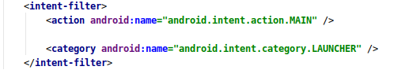

Sqlite implementation
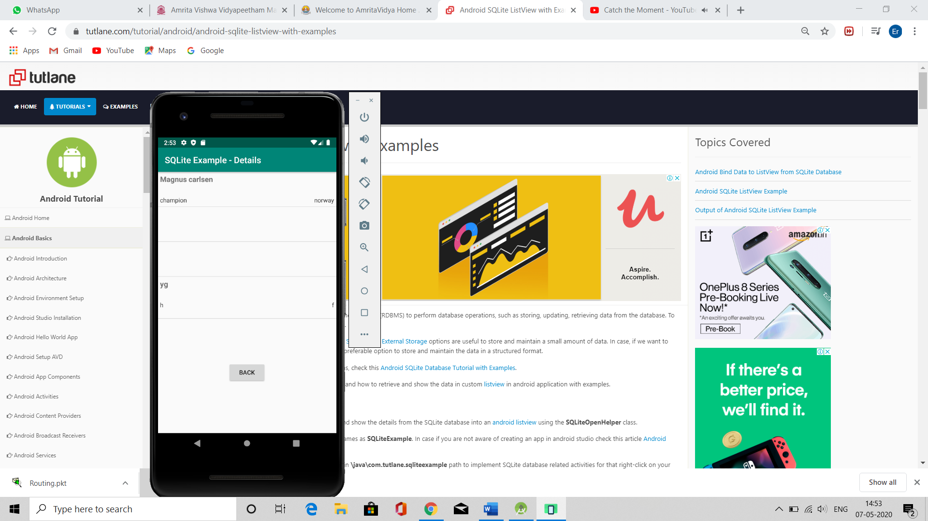
Activitymain.xml
<?xml version="1.0" encoding="utf-8"?>
<LinearLayout xmlns:android="http://schemas.android.com/apk/res/android"
android:orientation="vertical" android:layout_width="match_parent"
android:layout_height="match_parent">
<TextView
android:id="@+id/fstTxt"
android:layout_width="wrap_content"
android:layout_height="wrap_content"
android:layout_marginLeft="100dp"
android:layout_marginTop="150dp"
android:text="Name" />
<EditText
android:id="@+id/txtName"
android:layout_width="wrap_content"
android:layout_height="wrap_content"
android:layout_marginLeft="100dp"
android:ems="10"/>
<TextView
android:id="@+id/secTxt"
android:layout_width="wrap_content"
android:layout_height="wrap_content"
android:text="Location"
android:layout_marginLeft="100dp" />
<EditText
android:id="@+id/txtLocation"
android:layout_width="wrap_content"
android:layout_height="wrap_content"
android:layout_marginLeft="100dp"
android:ems="10" />
<TextView
android:id="@+id/thirdTxt"
android:layout_width="wrap_content"
android:layout_height="wrap_content"
android:text="Designation"
android:layout_marginLeft="100dp" />
<EditText
android:id="@+id/txtDesignation"
android:layout_width="wrap_content"
android:layout_height="wrap_content"
android:layout_marginLeft="100dp"
android:ems="10" />
<Button
android:id="@+id/btnSave"
android:layout_width="wrap_content"
android:layout_height="wrap_content"
android:layout_marginLeft="100dp"
android:text="Save" />
</LinearLayout>

List_row.xml
<?xml version="1.0" encoding="utf-8"?>
<RelativeLayout xmlns:android="http://schemas.android.com/apk/res/android"
android:layout_width="fill_parent"
android:layout_height="wrap_content"
android:orientation="horizontal"
android:padding="5dip" >
<TextView
android:id="@+id/name"
android:layout_width="wrap_content"
android:layout_height="wrap_content"
android:textStyle="bold"
android:textSize="17dp" />
<TextView
android:id="@+id/designation"
android:layout_width="wrap_content"
android:layout_height="wrap_content"
android:layout_below="@id/name"
android:layout_marginTop="7dp"
android:textColor="#343434"
android:textSize="14dp" />
<TextView
android:id="@+id/location"
android:layout_width="wrap_content"
android:layout_height="wrap_content"
android:layout_alignBaseline="@+id/designation"
android:layout_alignBottom="@+id/designation"
android:layout_alignParentRight="true"
android:textColor="#343434"
android:textSize="14dp" />
</RelativeLayout>

Details.xml
<?xml version="1.0" encoding="utf-8"?>
<LinearLayout xmlns:android="http://schemas.android.com/apk/res/android"
android:layout_width="fill_parent"
android:layout_height="fill_parent"
android:orientation="vertical" >
<ListView
android:id="@+id/user_list"
android:layout_width="fill_parent"
android:layout_height="wrap_content"
android:dividerHeight="1dp" />
<Button
android:id="@+id/btnBack"
android:layout_width="wrap_content"
android:layout_height="wrap_content"
android:layout_gravity="center"
android:layout_marginTop="20dp"
android:text="Back" />
</LinearLayout>

Mainactviyu.java
package com.example.contactapp;
import android.content.Intent;
import android.os.Bundle;
import android.view.View;
import android.widget.Button;
import android.widget.EditText;
import android.widget.Toast;
import androidx.appcompat.app.AppCompatActivity;
public class MainActivity extends AppCompatActivity {
EditText name, loc, desig;
Button saveBtn;
Intent intent;
@Override
protected void onCreate(Bundle savedInstanceState) {
super.onCreate(savedInstanceState);
setContentView(R.layout.activity_main);
name = (EditText)findViewById(R.id.txtName);
loc = (EditText)findViewById(R.id.txtLocation);
desig = (EditText)findViewById(R.id.txtDesignation);
saveBtn = (Button)findViewById(R.id.btnSave);
saveBtn.setOnClickListener(new View.OnClickListener() {
@Override
public void onClick(View v) {
String username = name.getText().toString()+"\n";
String location = loc.getText().toString();
String designation = desig.getText().toString();
DbHandler dbHandler = new DbHandler(MainActivity.this);
dbHandler.insertUserDetails(username,location,designation);
intent = new Intent(MainActivity.this,DetailsActivity.class);
startActivity(intent);
Toast.makeText(getApplicationContext(), "Details Inserted Successfully",Toast.LENGTH_SHORT).show();
}
});
}
}
detailsactivity.java
package com.example.contactapp;
import android.content.Intent;
import android.os.Bundle;
import android.view.View;
import android.widget.Button;
import android.widget.ListAdapter;
import android.widget.ListView;
import android.widget.SimpleAdapter;
import androidx.appcompat.app.AppCompatActivity;
import java.util.ArrayList;
import java.util.HashMap;
public class DetailsActivity extends AppCompatActivity {
Intent intent;
@Override
protected void onCreate(Bundle savedInstanceState) {
super.onCreate(savedInstanceState);
setContentView(R.layout.details);
DbHandler db = new DbHandler(this);
ArrayList<HashMap<String, String>> userList = db.GetUsers();
ListView lv = (ListView) findViewById(R.id.user_list);
ListAdapter adapter = new SimpleAdapter(DetailsActivity.this, userList, R.layout.list_row,new String[]{"name","designation","location"}, new int[]{R.id.name, R.id.designation, R.id.location});
lv.setAdapter(adapter);
Button back = (Button)findViewById(R.id.btnBack);
back.setOnClickListener(new View.OnClickListener() {
@Override
public void onClick(View v) {
intent = new Intent(DetailsActivity.this,MainActivity.class);
startActivity(intent);
}
});
}
}
DBhandler.java
package com.example.contactapp;
import android.content.ContentValues;
import android.content.Context;
import android.database.Cursor;
import android.database.sqlite.SQLiteDatabase;
import android.database.sqlite.SQLiteOpenHelper;
import java.util.ArrayList;
import java.util.HashMap;
public class DbHandler extends SQLiteOpenHelper {
private static final int DB_VERSION = 1;
private static final String DB_NAME = "usersdb";
private static final String TABLE_Users = "userdetails";
private static final String KEY_ID = "id";
private static final String KEY_NAME = "name";
private static final String KEY_LOC = "location";
private static final String KEY_DESG = "designation";
public DbHandler(Context context){
super(context,DB_NAME, null, DB_VERSION);
}
@Override
public void onCreate(SQLiteDatabase db){
String CREATE_TABLE = "CREATE TABLE " + TABLE_Users + "("
+ KEY_ID + " INTEGER PRIMARY KEY AUTOINCREMENT," + KEY_NAME + " TEXT,"
+ KEY_LOC + " TEXT,"
+ KEY_DESG + " TEXT"+ ")";
db.execSQL(CREATE_TABLE);
}
@Override
public void onUpgrade(SQLiteDatabase db, int oldVersion, int newVersion){
// Drop older table if exist
db.execSQL("DROP TABLE IF EXISTS " + TABLE_Users);
// Create tables again
onCreate(db);
}
// **** CRUD (Create, Read, Update, Delete) Operations ***** //
// Adding new User Details
void insertUserDetails(String name, String location, String designation){
//Get the Data Repository in write mode
SQLiteDatabase db = this.getWritableDatabase();
//Create a new map of values, where column names are the keys
ContentValues cValues = new ContentValues();
cValues.put(KEY_NAME, name);
cValues.put(KEY_LOC, location);
cValues.put(KEY_DESG, designation);
// Insert the new row, returning the primary key value of the new row
long newRowId = db.insert(TABLE_Users,null, cValues);
db.close();
}
// Get User Details
public ArrayList<HashMap<String, String>> GetUsers(){
SQLiteDatabase db = this.getWritableDatabase();
ArrayList<HashMap<String, String>> userList = new ArrayList<>();
String query = "SELECT name, location, designation FROM "+ TABLE_Users;
Cursor cursor = db.rawQuery(query,null);
while (cursor.moveToNext()){
HashMap<String,String> user = new HashMap<>();
user.put("name",cursor.getString(cursor.getColumnIndex(KEY_NAME)));
user.put("designation",cursor.getString(cursor.getColumnIndex(KEY_DESG)));
user.put("location",cursor.getString(cursor.getColumnIndex(KEY_LOC)));
userList.add(user);
}
return userList;
}
// Get User Details based on userid
public ArrayList<HashMap<String, String>> GetUserByUserId(int userid){
SQLiteDatabase db = this.getWritableDatabase();
ArrayList<HashMap<String, String>> userList = new ArrayList<>();
String query = "SELECT name, location, designation FROM "+ TABLE_Users;
Cursor cursor = db.query(TABLE_Users, new String[]{KEY_NAME, KEY_LOC, KEY_DESG}, KEY_ID+ "=?",new String[]{String.valueOf(userid)},null, null, null, null);
if (cursor.moveToNext()){
HashMap<String,String> user = new HashMap<>();
user.put("name",cursor.getString(cursor.getColumnIndex(KEY_NAME)));
user.put("designation",cursor.getString(cursor.getColumnIndex(KEY_DESG)));
user.put("location",cursor.getString(cursor.getColumnIndex(KEY_LOC)));
userList.add(user);
}
return userList;
}
// Delete User Details
public void DeleteUser(int userid){
SQLiteDatabase db = this.getWritableDatabase();
db.delete(TABLE_Users, KEY_ID+" = ?",new String[]{String.valueOf(userid)});
db.close();
}
// Update User Details
public int UpdateUserDetails(String location, String designation, int id){
SQLiteDatabase db = this.getWritableDatabase();
ContentValues cVals = new ContentValues();
cVals.put(KEY_LOC, location);
cVals.put(KEY_DESG, designation);
int count = db.update(TABLE_Users, cVals, KEY_ID+" = ?",new String[]{String.valueOf(id)});
return count;
}
}

manifest.xml
<?xml version="1.0" encoding="utf-8"?>
<manifest xmlns:android="http://schemas.android.com/apk/res/android"
package="com.example.contactapp">
<application
android:allowBackup="true"
android:icon="@mipmap/ic_launcher"
android:label="@string/app_name"
android:roundIcon="@mipmap/ic_launcher_round"
android:supportsRtl="true"
android:theme="@style/AppTheme">
<activity android:name=".MainActivity">
<intent-filter>
<action android:name="android.intent.action.MAIN" />
<category android:name="android.intent.category.LAUNCHER" />
</intent-filter>
</activity>
<activity android:name=".DetailsActivity" android:label="SQLite Example - Details"></activity>
</application>
</manifest>

